SOFTWARE REQUIREMENTS SPECIFICATION

**For**

**Event Management System**

**Prepared by:-**

*Team 9*

**1. Introduction**

**1.1 Purpose**

The main objective of this document is to illustrate the requirements of the project Event Management system. The document gives the detailed description of the both functional and non-functional requirements proposed by the client.The purpose of this project is to provide a friendly environment to organize the event for college students to showcase their talents.The main purpose of this project is to maintain easy circulation system using computers and to provide different reports. This project describes the hardware and software interface requirements using ER diagrams and UML diagrams.

**1.2 Document Conventions**

* Entire document should be justified.
* Convention for Main title
* Font face: Times New Roman
* Font style: Bold
* Font Size: 14
* Convention for Sub title
* Font face: Times New Roman
* Font style: Bold
* Font Size: 12
* Convention for body
  + - Font face: Times New Roman
    - Font Size: 12

**1.3 Scope of Development Project**

Event Management System is basically **designed to organize** technical and non-technical events for engineering students to showcase their talents. The technical events include project expos, paper presentations, and hackathons. Students can participate in either technical or non-technical events, not both.These events can generate innovative solutions to various problem statements. The project will provide a complete user interface for the event management process. The Event Management System can update or insert student information based on their registration.

The project can be easily implemented under various situations. We can add new features as and when we require, making reusability possible as there is flexibility in all the modules.

The language used for developing the project is Java as it offers several advantages compared to other languages, including performance, tool availability, cross-platform compatibility, libraries, cost (freely available), and development process.

**2. Overall Descriptions**

**2.1 Product Perspective**

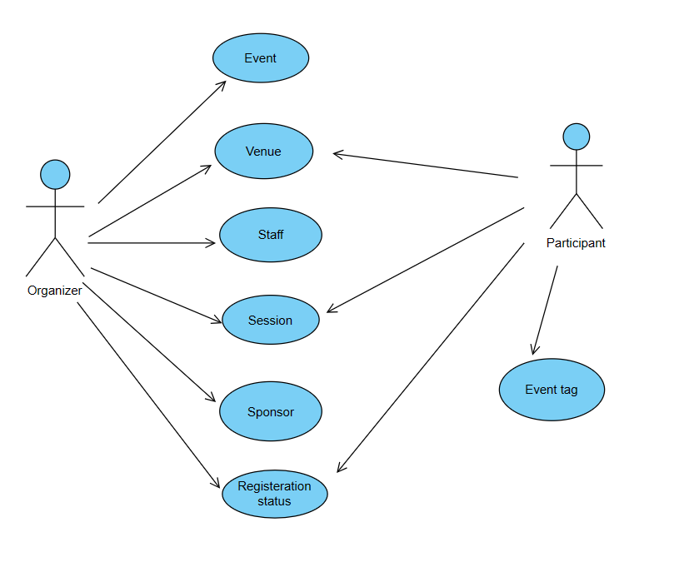

The system encompasses two main user categories: organizers and participants. Users, identified as either staff or students, engage with the system to search for events through various criteria such as event name or a unique identifier. The staff, responsible for managing events, can efficiently add or update event details and handle user requests within the system. Users have the capability to request event participation, renew event registrations, and complete event check-ins, adhering to predefined criteria. The system streamlines event management processes, offering a user-friendly experience for both staff and participants.

**2.2 Product Function**

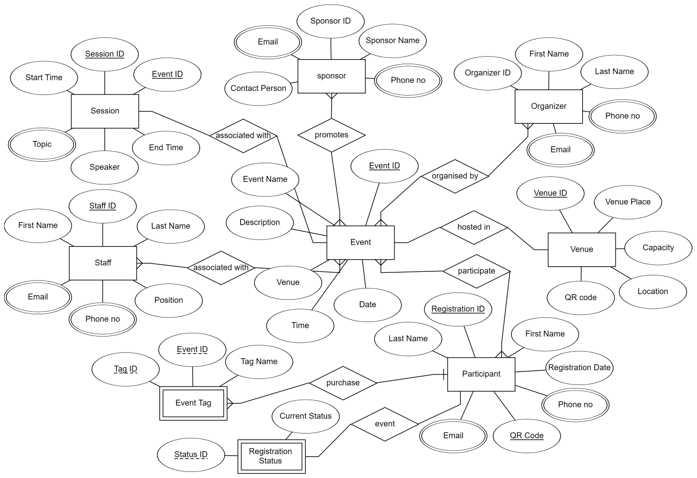

The Event Management System is a sophisticated application designed to streamline the planning and execution of events within a college environment. With a user-friendly interface, event organizers can effortlessly create, update, and delete event information, fostering efficient management. Notable features include ticket scanning and check-in procedures to ensure seamless entry for attendees. The system prioritizes access control measures, safeguarding the integrity and privacy of event data. Understanding the diverse needs of event organizers, the platform facilitates dynamic event creation, scheduling, and promotion, empowering organizers to tailor each experience. Attendees benefit from a straightforward registration process and easy ticket purchasing, enhancing overall user satisfaction. The system's database structure, as illustrated in the entity relationship diagram, supports optimal storage and retrieval of crucial event details. From workshops to large-scale conferences, this Event Management System provides a comprehensive solution for diverse college events, ensuring a smooth and successful execution.

**2.3 User Classes and Characteristics**

For the Event Management System, we can define user classes and characteristics to cater to the diverse roles involved in organizing and participating in events. The primary user classes are Event Organizer and Attendee.

Event Organizer:

* As the key administrator, the Event Organizer enjoys privileged access to manage all aspects of events efficiently. Their features include:
* Creating and updating events.
* Managing event schedules and promotions.
* Overseeing attendee registration and ticket sales.
* Implementing ticket scanning and check-in procedures during events.
* Accessing detailed reports on event analytics.

Attendee:

Attendees, representing students and staff, benefit from user-friendly features tailored for a seamless event experience. Their functionalities encompass:

* Viewing event details, schedules, and promotional information.
* Registering for events and purchasing tickets online.
* Accessing personal event history and purchased tickets.
* Requesting information on upcoming events.
* Providing feedback on attended events for organizers' review.

This user-centric approach ensures that both organizers and attendees can navigate the Event Management System efficiently, fostering successful and engaging events within the college community.

**2.4 Assumptions and Dependencies**

Assumptions:

* The event management system assumes the implementation of error-free coding practices for seamless functionality.
* The system assumes a user-friendly interface, prioritizing ease of use for all participants and organizers.
* Information about events, organizers, and attendees should be stored in a reliable and accessible database.
* The system assumes sufficient storage capacity and fast database access for efficient data handling.
* A search facility is assumed to be integrated into the system to enable quick and convenient access to event-related information.
* The event management system is expected to operate continuously, supporting event-related activities around the clock.
* Users should have the flexibility to access the system from any computer with internet browsing capabilities.
* Proper usernames and passwords are assumed to be required for secure access and user-specific actions.

Dependencies:

* The system's functionality depends on specific hardware and software requirements for seamless operation.
* The development and functioning of the project depend on adhering to the listed requirements and specifications.
* End-users, especially administrators, are dependent on having a comprehensive understanding of the event management system.
* The system relies on the availability of a reporting mechanism to store and retrieve essential data related to events.
* Proper functioning is dependent on integrating and maintaining a database accessible by the event management system.
* Any updates or changes to event information must be accurately recorded in the database to ensure reliable data retrieval and reporting.

**2.5 Requirement Software Configuration:-**

This software package is developed using java as front end which is supported by sun micro system. Microsoft SQL Server as the back end to store the database. Operating System: Windows NT, windows 98, Windows XP Language: Java Runtime Environment, Net beans 7.0.1 (front end) Database: MS SQL Server (back end) Hardware Configuration:- Processor: Pentium(R)Dual-core CPU Hard Disk: 40GB RAM: 256 MB or more

**2.6 Data Requirement**

The Event Management System relies on user inputs for event creation, scheduling, and attendee registration. User queries generate outputs like event details, schedules, and attendee accounts, ensuring a seamless experience. The system's functionality is driven by accurate database inputs, secure access controls, and real-time updates. Dependencies include effective database integration, secure transactions, and precise event data for optimal performance. The system excels in user-friendly event management, ensuring efficient ticketing services and streamlined access control procedures.

**3. External Interface Requirement**

**3.1 GUI**

The Event Management System offers an intuitive graphical interface for seamless user and administrator interactions. Key features include:

* Quick access to event reports, schedules, and attendee details.
* Customizable interface for administrators.
* Standardized template across all modules for consistency.

Login Interface:Users and administrators can register, create accounts, and log in securely. Incorrect entries prompt error messages for correction.

Search:Efficient search functionality allows users to find events based on criteria such as type and title.

Categories View:The system displays event categories, enabling administrators to add, edit, or delete categories.

Control Panel:Administrator control panels facilitate user and resource management, lending options, and event oversight.

**4. System Features**

To ensure user satisfaction and security, the Event Management System incorporates the following features:

* Members authenticate using unique IDs for secure access to the system.
* Administrators monitor and update account status.
* Pop-up alerts notify members attempting to exceed event registration limits.
* Administrators manage fines for overdue registrations.
* Members can only access and manage their own accounts.
* Administrators have privileged access to oversee and manage all member accounts.

**5. Other Non-functional Requirements**

**5.1 Performance Requirement**

* The Event Management System is designed to serve multiple campuses efficiently.
* Fast and accurate performance is essential for handling staff and student interactions.
* The system must handle errors effectively to prevent data loss and downtime.
* It should robustly accommodate a large volume of data, including numerous events and users.

**5.2 Safety Requirement**

* Periodic database backups are essential to prevent data loss due to system crashes or virus attacks.
* A reliable UPS/inverter system is necessary to mitigate the impact of power supply failures.

**5.3 Security Requirement**

* The system ensures database security through encryption.
* Users have limited access rights; normal users can only read information, not modify.
* Proper user authentication is implemented to safeguard against unauthorized access.
* Admins and members have separate accounts to maintain access control.

**5.4 Requirement attributes**

* Multiple admins can contribute to the project, ensuring collaborative development.
* The project is open source, fostering transparency and community involvement.
* Quality and user-friendliness are prioritized for ease of use and installation.

**5.5 Business Rules**

Enforce business policies, including project costs and discount offers.

Users must adhere to legal and ethical guidelines; any violation is strictly prohibited.

**5.6 User Requirement**

* System users, including members and administrators (librarians), are assumed to have varying levels of computer knowledge.
* Administrators should possess in-depth knowledge to handle system maintenance and resolve issues.
* The system provides user-friendly interfaces, manuals, and online help for seamless user experience.
* Admins offer essential facilities like backup and recovery, password recovery, data migration, auto-recovery, file organization, and regular system maintenance for efficient functioning.

**6. Other Requirements**

**6.1 Data and Category Requirement**

The Event Management System accommodates diverse user categories, including organizers, participants, and administrators, each with specific access rights. Administrators enjoy comprehensive privileges, while other users possess limited access, allowing them to retrieve information but not modify it. The system incorporates various event categories, each structured with specific details. Users can expect relevant data presentation based on event categories. The organization and coding of categories and their associated data are designed for efficient management and retrieval within the system.

## 6.2 Class Diagram

A class is an abstract, user-defined description of a type of data. It identifies the attributes of the data and the operations that can be performed on instances (i.e. objects) of the data. A class of data has a name, a set of attributes that describes its characteristics, and a set of operations that can be performed on the objects of that class. The classes’ structure and their relationships to each other frozen in time represent the static model. In this project there are certain main classes

which are related to other classes required for their working. There are different kinds of relationships between the classes as shown in the diagram like normal association, aggregation, and generalization. The relationships are depicted using a role name and multiplicities. Here ‘Librarian’, ‘Member’ and ‘Books’ are the most important classes which are related to other classes

